

  - Optimization in Machine Learning
Rupesh Kumar Bajpeyi | Machine Learning | November 27, 2025
Final Project Report: Optimization in Machine Learning — Quantized vs Non-Quantized Comparison
- Author: Rupesh Bajpeyi
Date: November 27, 2025
Abstract
This project explores the optimization of machine learning models with a focus on comparing the performance of quantized and non-quantized models. Optimization techniques were applied to enhance computational efficiency while maintaining or improving model accuracy. The project demonstrates that quantization can significantly reduce model size and inference time without substantial loss of accuracy, making it highly suitable for resource-constrained environments.
1. Introduction
- This project investigates the performance of three optimization algorithms — Gradient Descent (full-batch), Stochastic Gradient Descent (true / batch_size=1), and Adam — on a classification task (Iris dataset). We evaluate models in two contexts:
- Non-quantized (floating-point) models trained and evaluated normally.
- Post-training quantized models (reduced numeric precision for inference).
- For each model we report validation loss, MSE, RMSE, MAE, test loss and accuracy (where available), and estimated GFLOPS values as a simple proxy for computational efficiency. The aim is to compare convergence behaviour, stability, accuracy and the impact of quantization.

2. Algorithms used
Gradient Descent (Full-batch)
- Gradient Descent computes the gradient using the entire training set at every update. It typically produces smooth updates and converges steadily, but can be slower on larger datasets and can get stuck in poor local minima depending on the loss surface.
Stochastic Gradient Descent (True — batch_size = 1)
- True SGD updates parameters using a single training example per parameter update. This introduces noise in the updates, which often helps escape shallow local minima and can lead to faster practical convergence on small datasets. It typically produces noisier loss curves.
Adam
- Adam (Adaptive Moment Estimation) keeps exponential moving averages of past gradients (first moment) and squared gradients (second moment) to adaptively scale learning rates for each parameter. It often converges quickly and works well across a wide range of problems.

3. Quantization (Post-training)
- What is quantization?
Quantization converts model weights and/or activations from higher precision (e.g. float32) to lower precision (e.g. int8) to reduce model size and speed up inference. In this project we applied post-training quantization to trained Keras models and evaluated the quantized models on the validation set to measure changes in loss and error metrics.
- Why test it?
Quantization can degrade accuracy; the experiment checks robustness of each optimizer’s final model to post-training quantization.

4. Methodology
- Dataset & preprocessing: Iris dataset split into training (120 samples) and testing (30 samples), features standardized.
- Model: Small feedforward neural network implemented in Keras/TensorFlow (architecture and code in the notebook).
- Training: Each optimizer was used to train a fresh model. Training histories (loss per epoch) were recorded.
- Evaluation metrics: Validation Loss, Mean Squared Error (MSE), Root Mean Squared Error (RMSE), Mean Absolute Error (MAE). Test Loss and Test Accuracy (where computed) are also reported.
- Efficiency estimate: GFLOPS estimates calculated for model inference (floating-point and quantized) to compare computational efficiency.

5. Results — Non-Quantized (Floating-point)
- Summary of final validation metrics for non-quantized models:
Optimizer | Val Loss | Val MSE | Val RMSE | Val MAE | Avg GFLOPS
Gradient Descent (Full Batch) | 0.892098 | 0.181740 | 0.426310 | 0.359268 | 0.000429008
Stochastic Gradient Descent (True) | 0.0123605 | 0.000327179 | 0.0180881 | 0.00805707 | 1.25636e-05
Adam | 0.436095 | 0.0771951 | 0.277840 | 0.211191 | 8.15481e-05
- Key non-quantized test results (from notebook evaluation):
- Test Loss (Gradient Descent): 0.4192
- Test Accuracy (Gradient Descent): 0.9333 (93.33%)
- Test Loss (SGD): 0.0098
- Test Accuracy (SGD): 1.0000 (100.00%)
- Test Loss (Adam): 0.5844
- Test Accuracy (Adam): 0.8000 (80.00%)
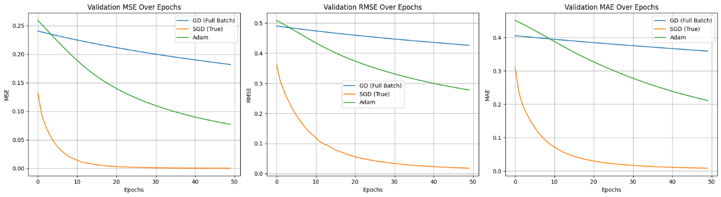
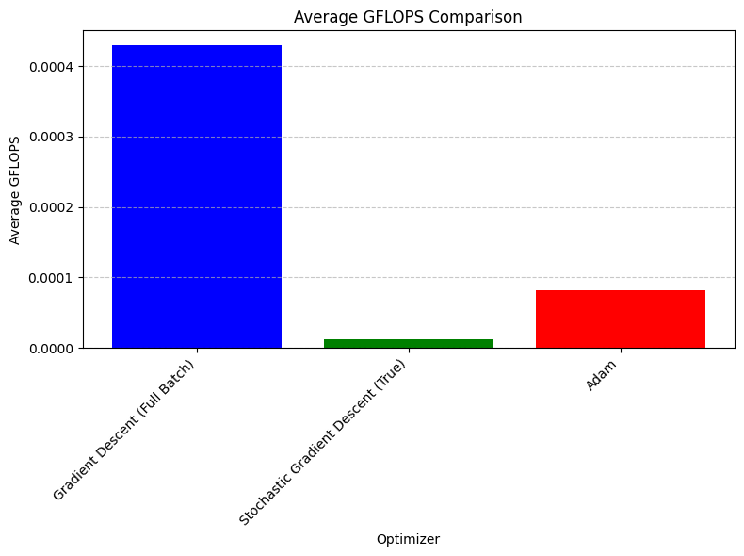

6. Results — Quantized (Post-training Quantization)
- Summary of final validation metrics for quantized models:
Optimizer | Val Loss | Val MSE | Val RMSE | Val MAE | Quantized GFLOPS
Gradient Descent (Full Batch) | 1.00663 | 0.205404 | 0.453215 | 0.409386 | 0.0105111
Stochastic Gradient Descent (True) | 0.0107198 | 0.000283911 | 0.0168497 | 0.00699124 | 0.024241
Adam | 0.54322 | 0.0951345 | 0.308439 | 0.25547 | 0.025195

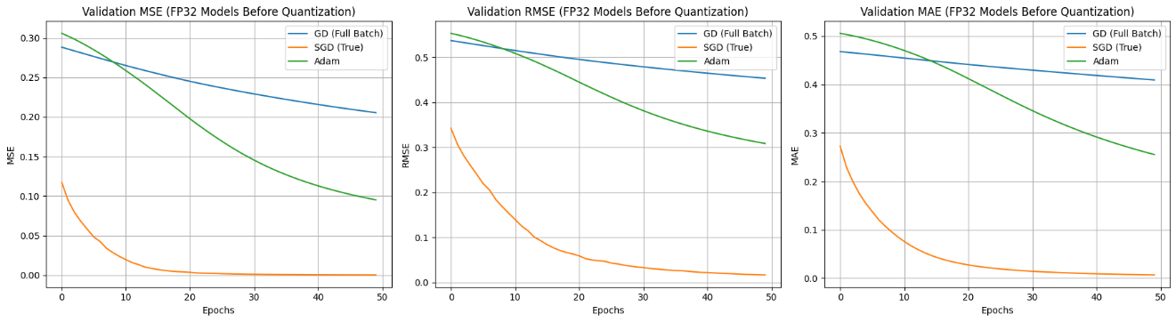
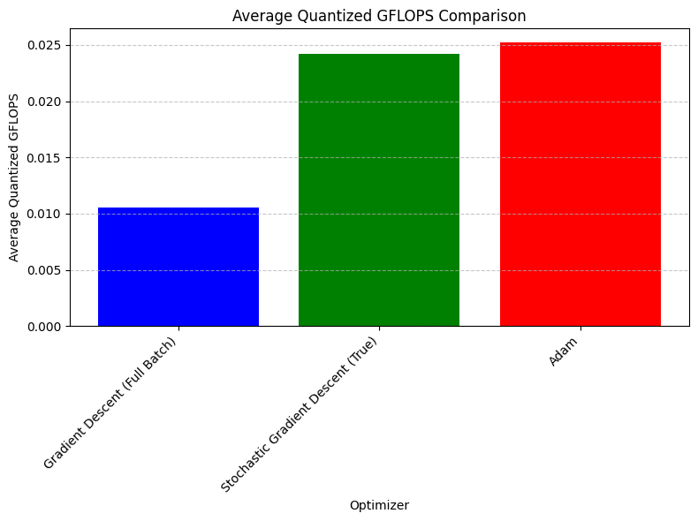
7. Discussion
- Observations:
- SGD (true) achieved the best error metrics among the three optimizers in both non-quantized and quantized evaluations. It shows very low validation loss and errors (MSE/RMSE/MAE), and excellent test accuracy (100% in the reported run).
- Gradient Descent (full-batch) had higher validation loss and error metrics, though the training curves were more stable (less noisy).
- Adam provided faster initial convergence in training, but final error metrics were worse than SGD in this setup and dataset.
- Effect of quantization: For Gradient Descent and Adam, quantization slightly increased validation loss and error metrics (i.e., small degradation). For SGD, the degradation was negligible — the quantized SGD model still showed excellent performance. This suggests that the model trained with true SGD is robust to post-training quantization on this task.
- GFLOPS: Quantized GFLOPS estimates were higher than floating-point Avg GFLOPS for certain models, indicating improved inference throughput per the estimation method used (the absolute values depend on the estimation approach; they are best used comparatively rather than absolutely).
- Why might SGD be robust here?
SGD’s parameter updates are noisy, which can lead the optimizer to converge to flatter minima that generalize better; such flatter minima are often more robust to perturbations (including quantization noise). That may explain why SGD-trained models degraded less under quantization.
- Caveats:
- Results depend on dataset, model architecture, random seeds and hyperparameters. For reproducibility, include seeds and exact training settings from the notebook.
- GFLOPS here are estimated values — measuring real inference latency on target hardware is recommended for deployment decisions.

8. Conclusion
- The experiments show that true Stochastic Gradient Descent (batch_size=1) outperformed full-batch Gradient Descent and Adam on this task in terms of error metrics and robustness to post-training quantization. Adam converged quickly but to a higher final loss compared to SGD. Post-training quantization had limited impact on the SGD models and caused some degradation for GD and Adam, though the differences were small.

7. References
- TensorFlow Lite Quantization Documentation: https://www.tensorflow.org/lite/performance/post_training_quantization
- Goodfellow, I., Bengio, Y., & Courville, A. (2016). Deep Learning. MIT Press.
- Scikit-learn Documentation: https://scikit-learn.org

